Name: _____________________________ Date: _____________Total Marks: ___________________

Reading Data from a Sequential-Access Text File

Instructions

- Use a text editor such as Notepad, create a text file and name it Sample.dat.
- Type the following five lines into the Sample.dat file:
10,Bryan,Barker,1000.45
20,Geof,Nott,350.65
30,Edmond,Smith,500.33
40,Dave,Brant,124.15
50,Sandy,Dawn,780.00
- Create a new windows application named ReadSequentialAccessFileForm.
- Select Form1.cs and rename it to ReadSequentialAccessFileForm.cs. When Visual Studio prompts you to rename the Form1 code element, click Yes.
- Add two Button controls to the form. Change their name properties to openButton, and nextButton. Arrange the controls and change their Text properties as shown in Figure 1.
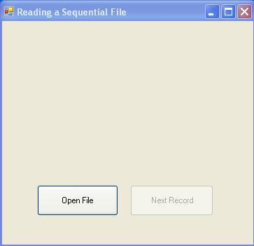
Figure 1 – Reading sequential-access files
- Right-click the References node in Solution Explorer and select Add Reference. Select the Browse tab in the Add Reference dialog box. Browse to the BankLibrary folder. Add reference to BankLibrary.dll.
- Add an include for the BankLibrary namespace into the ReadSequentialAccessFileForm class, as the following code shows:

using System;
using System.Windows.Forms;
using System.IO;
using BankLibrary;

- Inherit class ReadSequentialAccessFileForm from BankUIForm class (Figure 2).
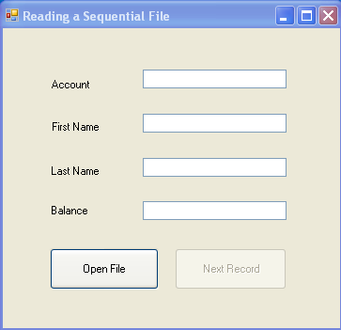
Figure 2 – Reading sequential-access files

- Declare two private variables before the constructor definition:

private StreamReader fileReader; // reads data from a text file
private FileStream input; // maintains connection to a file

- Double-click the openButton button to attach a Click event handler to it. Add the following code to the event handler:

private void openButton_Click( object sender, EventArgs e )
{

// TODO: create dialog box enabling user to open file

// TODO: exit event handler if user clicked Cancel

// TODO: get specified file name

// TODO: show error if user specified invalid file

// TODO: create FileStream to obtain read access to file

// TODO: set file from where data is read

}

- Double-click the nextButton button to attach a Click event handler to it. Add the following code to the event handler:

private void nextButton_Click( object sender, EventArgs e )
{
try
{
// get next record available in file
string inputRecord = fileReader.ReadLine();
string[] inputFields; // will store individual pieces of data

if ( inputRecord != null )
{
inputFields = TODO

// TODO: Record record = new Record(
Convert.ToInt32( inputFields[ 0 ] ), inputFields[ 1 ],
inputFields[ 2 ], Convert.ToDecimal( inputFields[ 3 ] ) );

// copy string array values to TextBox values
SetTextBoxValues( inputFields );
} // end if
else
{
// TODO: close StreamReader
// TODO: close FileStream if no Records in file
// TODO: enable Open File button
// TODO: disable Next Record button
// TODO: Clear All TextBox Controls

// TODO: notify user if no Records in file
} // end else
} // end try
catch ( IOException )
{
MessageBox.Show( "Error Reading from File", "Error",
MessageBoxButtons.OK, MessageBoxIcon.Error );
} // end catch
} // end method nextButton_Click

- Save and Build the project. Read records from Sample.dat, and verify the contents of each record.

